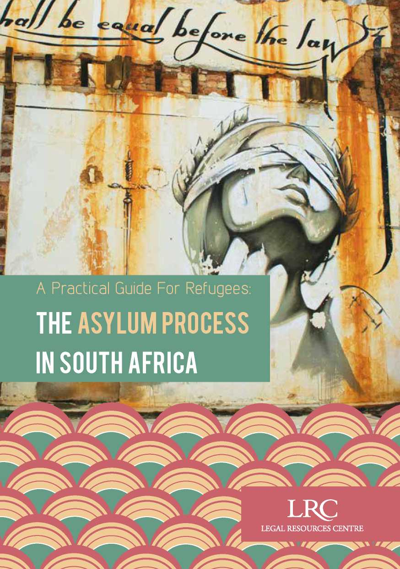

LRC

LEGAL RESOURCES CENTRE

Edited by: Estelle Hebron-Jones, John Irvine, Charlene May, Mandy Mudarikwa and Laurie Rose-Innes

Acknowledgements: Lawyers for Human Rights

Design: Design for development, [www.d4d.co.za](http://www.d4d.co.za)

Cover photo: Katerina Sonntagova/Design for development (Faith47, ‘All shall be equal before the law', the Freedom Charter series, Queen Victoria St, Cape Town)

Print: Corpnet

This guide was produced with the generous support of the Julia Taft Fund for Refugees through the US Embassy in Pretoria, South Africa.

A Practical Guide For Refugees: the asylum process in South Africa

This guide is for refugees, asylum-seekers and the organisations and activists that provide assistance to refugees and asylum-seekers. It is to be used as an initial resource when applying for asylum and gives a step-by-step overview of each stage of the process.

Please note that policies and regulations impacting refugees and asylum-seekers may change, so contact the Legal Resources Centre (LRC) to get the most recent information.

A directory of useful contacts at the back of this guide includes the contact details for each of the LRC regional offices located in Cape Town, Durban, Grahamstown and Johannesburg.

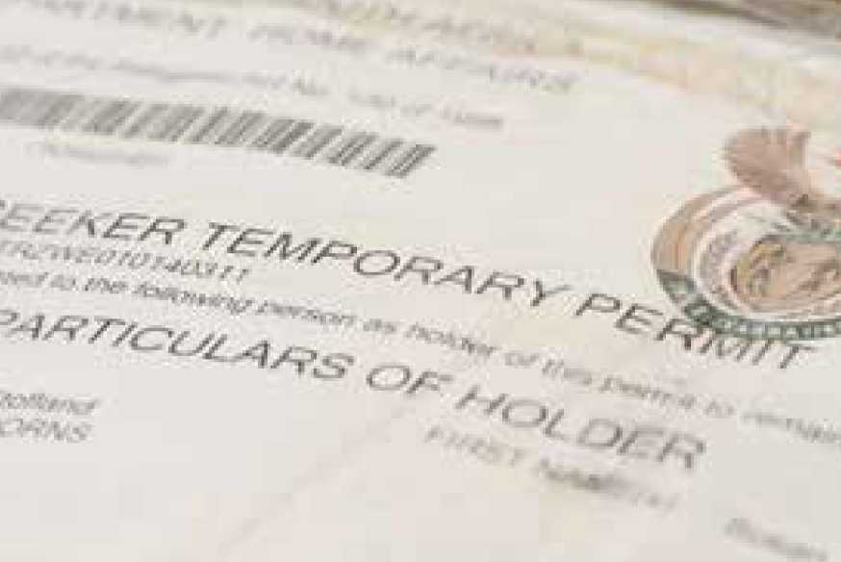

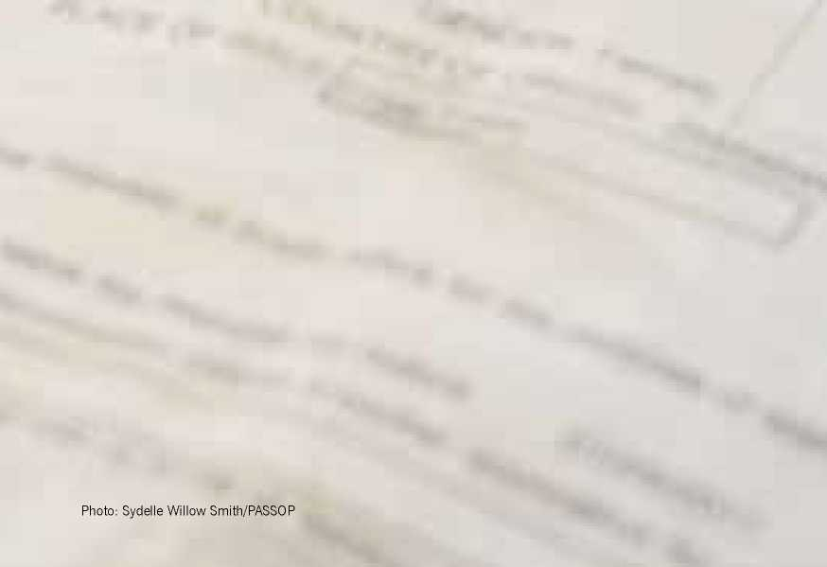

Contents

Applying for asylum 1-3

Getting to a Refugee Reception Office 1

Completing an Eligibility Determination Form at an RRO 1-2

Relatives and spouses claiming asylum 2-3

Once your Eligibility Determination Form is complete 3

Replacing a lost asylum-seeker permit 3

Awaiting a decision 4

Your status determination hearing 4

Receiving Your Decisio 5-7

If your asylum application is approved

5

If your asylum application is rejected 5-7

Withdrawal of refugee status 7

Applying for permanent residence 8

If you are arrested 9

Settling down in South Africa 10-11

Social services

10

Employment

10

Healthcare

10-11

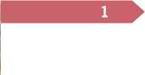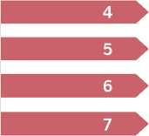



11

Long-term solutions

Directory

Education

12 13-16



Are you

A person who has left his or her country of origin because of a well-founded fear of persecution on account of:

* your race;
* religion;
* nationality;
* political opinion;
* tribe; or
* membership of a particular social group

-OR­

A person whose life, physical safety or freedom would be threatened on account of:

* external aggression;
* occupation;
* foreign domination; or
* other events seriously disturbing the public order in either part or the whole of your country of origin;

-OR-

* you are a dependant of a person who qualifies for refugee status in terms of the above provisions?

**If so, you could possibly be granted refugee status in South Africa.**

If you are granted refugee status you will receive a certificate that allows you to re­main in South Africa for four years; with this permit you can work and study. After four years, before your refugee status document expires, you must report to the Refugee Reception Office to renew the document in order to continue legally residing in South Africa.





APPLYING FOR ASYLUM

**No person may be denied the opportunity to apply for asylum.**

Getting to a Refugee Reception Office

When you arrive at a port of entry, which includes border posts and airports, you should request an **asylum transit permit**; this is valid for **14 days**. You will need to take your transit permit to the nearest **Refugee Reception Office** (RRO) within **14 days** of your arrival in order to com­plete an **Eligibility Determination Form for Asylum-Seekers**. This form is also called an **asylum application**. It is impor­tant for you to inform the officials if you do not speak English so that a translator can be appointed to assist you with complet­ing the form. You can find RROs in Cape Town, Durban, Musina, Port Elizabeth and Pretoria. Contact details for these of­fices are on page 13.

Completing an Eligibility Determination Form at an RRO

RROs can be difficult to access because many people seek asylum in South Africa. Be patient. You might have to queue mul­tiple times before submitting your Eligibil­ity Determination Form. If you have dif­ficulty accessing the RRO because of an expired transit permit, please contact the **LRC** for advice.

**If you come into contact with law enforcement prior to being issued with an asylum-seeker permit you should tell them you are seeking asylum in South Africa.**

New applicants are processed by country or region, so make sure you know when new applicants from **your country** are be­ing processed. This changes frequently, so contact the Department of Home Af­fairs or visit their website at **[www.home- affairs.gov.za](http://www.home-affairs.gov.za)** for details.

Once you gain access to the RRO you will have to fill out the Eligibility Determina­tion Form. If you need assistance filling out the form, the Refugee Reception Of­ficer **must** help you. Answer all questions honestly; after completing the form, you will have to swear to its truthfulness.

If you can, bring documentation with you that can verify:

* who you are;
* where you are from; and
* any events mentioned in your application.

The Refugee Reception Officer can make **copies** of these documents to keep, but must return the **originals** to you.

A file will be created for you, and you will be given a **file number**. Write this number down. If you do not understand English, please let the Refugee Reception Officer know so that an interpreter can be provided for you. You are also allowed to bring your own interpreter.

Relatives and spouses claiming asylum

Some people who have come to South Africa primarily because a family mem­ber has claimed asylum may also apply for asylum; these people are called de­pendants. They are usually wives, hus­bands, unmarried children under the age of 18, or aged or infirm family members of the person who has claimed asylum. The person who has claimed asylum must assist their dependants during the application process or apply on behalf of their dependants.

The principal asylum-seeker or dependant must provide **proof of relationship**. Proof of relationship may be established by documentary evidence, such as marriage or birth or baptismal certificates, or travel documents. If none of these is available, an **affidavit** (which is a written sworn statement) may be used to prove the rela­tionship. In the event that you bring minor relatives with you into South Africa you will have to apply to the Children's Court to be declared the child's legal guardian before they can be joined to your file. You must take the court order with you to the RRO as proof of the Court's decision. Unaccompanied Children

If an unaccompanied child enters South Africa with the intention of claiming asy­lum, the child will be brought before the Children's Court. The Children's Court may order that the child be assisted with their asylum application. In this event, a Department of Home Affairs representa­tive will provide assistance with the ap­plication process at the RRO.

Mentally disabled relatives or persons

If you bring a mentally disabled relative with you to South Africa when you seek asylum, he or she may be added to your file in some circumstances. If a mentally disabled person is applying for asylum in­dependently, he or she must be assisted with the application.

Once your Eligibility Determination Form is complete

Once your Eligibility Determination Form has been filled out, the Refugee Reception Officer **must** receive your application and issue a **Section 22 asylum-seeker permit**. You should sign the permit immediately.

With an asylum-seeker permit you may legally live, work and study in South Africa while your claim for asylum is being con­sidered. The asylum-seeker permit only shows that you have applied for asylum in South Africa; it **does not** confer refugee status on you. Your asylum-seeker permit functions as your identification document. You **must** carry it with you in case public authorities question you.

The asylum seeker permit is usually valid for three months. You can report to any of the RROs to renew your asylum-seeker permit before it expires. Most RROs have a separate line for the renewal of asylum­seeker permits. Sometimes, they will take your permit and ask you to return a few hours later to pick up the renewed permit. If you do not renew it on time, you may be issued with a fine.

Replacing a lost asylum­seeker permit

It is very difficult to replace a lost permit. Make certified copies of your permit and keep them in safe places with friends and family. Certified copies can be obtained at post offices, police stations and law of­fices. Also, remember the file number and case number on your permit. If you lose your permit you must report the loss at the nearest police station.

**The entire application process is FREE. Never give money to any staff member at the Refugee Reception Office.**





AWAITING A DECISION

As an asylum-seeker you may stay in South Africa until there has been a final decision on your asylum application. A final decision is either a decision grant­ing refugee status or a denial of refugee status given after all appeals or reviews have been exhausted.

Your status determination hearing

After receiving your asylum-seeker permit a **status determination hearing** with the **Refugee Status Determination Officer** should be scheduled. This could hap­pen at any time: from the day you receive your asylum-seeker permit, to a couple of months or even years after your applica­tion.

The Status Determination Officer will in­terview you to assess your asylum claim and ask you questions about statements you made in the Eligibility Determination Form. The questions may also be about other things (for example, your culture, language or specific events that occurred in your past). At the interview, you may bring a legal representative, an interpreter and any witnesses to help you with your asylum claim. You may also bring affida­vits from witnesses or any other evidence that is relevant to your case.

At the end of the interview you may be asked to wait for your decision or be told to come back at a later date for your deci­sion. If you have to come back for your decision then you will be issued with an­other asylum-seeker permit, which you must continue renewing until you receive a decision about your application.

**►**

**You are entitled to receive a decision on your application.**

Your permit may be withdrawn if you vio­late any conditions endorsed on the per­mit, become ineligible for asylum, or your application for asylum has been rejected or found to be ‘manifestly unfounded', ‘abusive' or ‘fraudulent'.





RECEIVING YOUR DECISION

If your asylum application is approved

If your application is approved you will be issued with a **Section 24 refugee status permit**, which allows you to live, work and study in South Africa. With this per­mit, you may apply for a **refugee identity document** and a **travel document**, which will act as your passport.

A refugee status permit is valid for four years. You must apply for the **renewal** of your permit at the RRO **three months** be­fore it expires. At the renewal, the Status Determination Officer will review your ap­plication and reassess your refugee status based on the situation in your country of origin. Ask if there is a separate queue for the renewal of refugee status permits.

If your asylum application is rejected

If your application is rejected then it will be classified as:

* “manifestly unfounded”, "abusive” or “fraudulent”; or
* “unfounded”.

If your application is classified as **“mani­festly unfounded”**, **“abusive”** or **“fraudu­lent”** the Status Determination Officer has found your application to be:

* based on grounds other than those listed in the Refugees Act;
* made with the purpose of defeating or evading criminal or civil proceed­ings or the consequences thereof, or after the refusal of one or more prior applications without any substantial change having occurred in the ap­plicant's personal circumstances or in the situation in his or her country of origin; or
* based on facts, information, docu­ments or representations which the applicant knows to be false.

If your application is rejected as ‘**mani­festly unfounded**', ‘**abusive**' or ‘**fraudu­lent**', the Refugees Act states that you will receive reasons for the rejection within five days of the decision, but because of backlogs the decision is generally given after some months when you report to the RRO to renew your permit. A copy of these reasons and the record of proceedings will be submitted to the Standing Com­mittee for Refugee Affairs (the Standing Committee) for mandatory review. Once you receive the decision you will have 14days in which to explain in writing why the rejection is incorrect in terms of the law in South Africa. This written explana­tion should be submitted directly to the Standing Committee on the details given on the rejection letter. It is advisable to seek legal assistance with writing the ex­planation above as you may have to make legal submissions pertaining to your ap­plication. If you are not able to submit the explanation within 14 days you can explain the reason why you did not do so when you submit your explanation. Seek legal assistance with this process as well. If your application is rejected as ‘**un­founded**', you have a **right to appeal** the decision. To do this, you must complete the prescribed **notice of appeal** form with an accompanying affidavit explaining the reasons for appeal within **30 days** of re­ceiving the rejection. This appeal must be lodged in person at the RRO. You should seek **legal assistance** in drafting your no­tice of appeal and affidavit, as you may have to make some legal submissions in the affidavit.

Once you have filed your notice of inten­tion to appeal, you will be issued with a **notice of hearing** at least ten days before the scheduled hearing. This will inform you of the date, time and place of your appeal hearing. Once you receive the no­tice of the hearing you must immediately inform your legal representative to enable them to have adequate time to prepare for your appeal. If you do not have legal as­sistance at this time then it is advisable for you to obtain the services of one im­mediately because of the legal submis­sions that would have to be made in your appeal. You must be **physically present** at the appeal hearing because the **Refu­gee Appeal Board** (RAB) will have to ask you questions regarding your appeal and claim.

You are allowed to have legal represen­tation at your appeal hearing and you should seek legal representation for this purpose. The RAB **must** make a decision within 90 days; however, it often takes longer than 90 days to finalise the deci­sion. Make sure you continue to renew your asylum-seeker permit while you wait for a decision.

If for any reason you are not able to attend your appeal, please let the RAB know so your appeal can be postponed. If you can­not do this before the appeal is heard, you should seek legal assistance with an ap­plication to the RAB asking them to is­sue you with another date. You must set out your reasons for failing to attend the original appeal hearing in the application. These reasons for failing to appear mustbe set out in an affidavit as is required by the RAB. If you do not submit this appli­cation requesting a new date to the RAB, the RAB can dismiss your refugee appli­cation.

The RAB can confirm, set aside or sub­stitute any decision taken by the Status Determination Officer.

If your application is rejected as unsuc­cessful, you can still seek review of the decision in the High Court. You should seek legal assistance to do this because your ability to do this successfully will de­pend on the facts of your case and the reason for rejection.

WITHDRAWAL OF REFUGEE STATUS

You could lose your refugee status if you:

* voluntarily obtain the protection or nationality of your country of origin;
* obtain the nationality of a new coun­try;
* voluntarily return to the country you left and take up residence there with the intention of settling there perma­nently; or
* no longer need to be protected in South Africa because the circum­stances in your country of origin have changed.

The state may also withdraw your refugee status if:

* it was granted erroneously on the ba­sis of an application which contained false information; or
* it was granted as a result of fraud, forgery, or false or misleading representation of importa nt facts in relation to the application.



APPLYING FOR PERMANENT RESIDENCE

As a recognised refugee, you have the right to apply for a permanent residence permit after five years of continuous resi­dence in South Africa from the date you were granted refugee status. Before you can apply for permanent residence, you have to apply to be **indefinitely declared as a refugee**. If you have dependants on your file then ensure that you mention that the application is for you and your dependants which you should list in the certification application. The Standing Committee will have to certify that you will remain a refugee indefinitely.

You will have to explain why you will remain a refugee indefinitely given the circumstances in your country. This cer­tification is not a right, it is granted after your application is considered with regard given to all applicable facts, particularly the reason you left your country of origin and the reason you cannot return.

You must seek legal assistance with this application because a rejection of the ap­plication means that the Standing Com­mittee may notify you of their intention to withdraw your refugee status.

Once you are certified as a refugee indefi­nitely then you must report to the Depart­ment of Home Affairs Civic Services to apply for permanent residence. You must keep your certification letter in a safe place as it would be one of the documents that you will have to submit with your per­manent residence application.



IF YOU ARE ARRESTED

If you are suspected on reasonable grounds of being an undocumented or il­legal foreigner, you must prove that you are permitted to be in the country. Having your asylum-seeker permit, refugee status permit or refugee identity document on you is the easiest way to prove your status in South Africa.

If you are arrested on the suspicion that you are not in the country legally, an of­ficer has 48 hours to verify that you are in the country illegally. If the officer does not do so within 48 hours, you **must** be released. While detained, you have the right to make one free phone call to locate your permit. You also have a right to legal representation. You have these rights im­mediately and you should be informed of these rights straight away.

You may not be detained for more than 30 days unless a Magistrate's Court reviews your detention.

If you are taken to Lindela Repatriation Centre, you should contact the **LRC** for assistance.

If you are seeking asylum in South Africa but are arrested before you are issued with an asylum-seeker permit, then you must immediately alert a lawyer. No person may be returned to a country where they would suffer persecution on the grounds listed at the beginning of this guide.



SETTLINg DOWN IN SOUTH AFRICA

Social Services

As an asylum-seeker or refugee, you are usually required to care for your own so­cial and economic needs. However, in certain cases, the South African govern­ment, United Nations High Commission for Refugees (UNHCR) or a non-govern­mental organisation can provide assis­tance. There are also many different re­ligious institutions that provide food and assistance to refugees, asylum-seekers and other vulnerable people.

There are four social grants that are avail­able to refugees who have been issued with a refugee status permit:

* **Disability grant** are available to refugees who are not able to work because of a mental or physical dis­ability.
* **Foster care grants** are available to refugees who are the guardians of foster children.
* **Care dependency grant** are avail­able if you are taking care of a child who has a severe disability and is in need of full-time and special care.
* **Social relief of distress grants** are usually only available to South Africans, but in extreme cases may be available to refugees who need emergency assistance.

Employment

As a refugee or asylum-seeker, you have a right to seek employment under fair conditions. This right is endorsed on your refugee or asylum-seeker permit.

There are laws protecting your right to work, for example:

* An employer cannot discriminate against you based on your immigra­tion status.
* You are protected from unfair work practices and dismissals.
* There are minimum working stand­ards such as hours of work and leave arrangements.

You are advised to familiarise yourself with these laws.

Healthcare

South Africa's health system consists of a private system and a government-run sys­tem. Many asylum-seekers and refugees find private healthcare to be expensive. Health services offered by government hospitals are generally offered at low cost, and community health clinics usuallyprovide free services. If you experience a health problem, you should go to your nearest local clinic. Make sure to bring your asylum-seeker permit or refugee sta­tus permit.

If you want to go to a government hos­pital you will need a referral letter from a local clinic. Make sure to bring your asy­lum-seeker permit or refugee status per­mit with you. At the hospital you will be asked to pay before services are rendered. In cases of emergency, you can go to a government hospital without a referral let­ter and receive treatment before paying.

**If you have a medical emergency, you cannot be denied access to medical services.**

Education

Everyone, including every adult, has a right to basic education. In South Africa, primary education is obligatory and it is a criminal offence to prevent a school-aged child from attending school. The govern­ment is obliged to provide adequate pri­mary education for all children including refugees and asylum-seekers. In South Africa, primary education runs from Grade 1 to Grade 7, which generally covers chil­dren aged 7 to 13.

As a parent or caregiver, you should reg­ister your children for primary education at the school closest to where you live. You must be able to provide the school with contact details of your family, includ­ing your physical and postal address, a certified copy of the child's permit or your permit, and an inoculation certificate. You can obtain an inoculation certificate from a local clinic. You do not have to have it at the time you register the child; you should be given three months to obtain it.

If you are struggling to obtain documen­tation for the child, the school cannot refuse to enrol the child because of the lack of these documents. This is because the law regulating the admission of learn­ers to public schools states that, in cases where the required documentation is not available, the principal must admit the child conditionally and help the parent to obtain the necessary documentation. When the required documentation is not available within three months of the child having been conditionally admitted to the school, the school governing body, in consultation with district officials, must attend to the matter by liaising with the relevant authorities and parents.

It is best to apply well in advance (from July onwards) because schools become full quickly.

If you are struggling with the payment of school fees you may request a fee exemp­tion. To do so, you need to provide proof of income. Proof of income can be a pay slip, affidavit or letter of support.



LONG-TERM SOLUTIONS

Long-term solutions, also called ‘durable solutions', generally involve refugees mov­ing within South Africa, back to their home countries, or to a third country of asylum. There are some situations in which the UNHCR will sponsor the movement of recognised refugees from one place to an­other. The situations are grouped under three categories:

* Voluntary repatriation;
* Resettlement; and
* Local integration.

**Voluntary repatriation** is when a refugee freely decides to return to his or her coun­try of origin. The UNCHR often promotes this as the best solution if conditions have changed and safe return is possible.

**Resettlement** is the assisted movement of a refugee to a country other than the country that first guaranteed refugee sta­tus. Resettlement is only possible in ex­ceptional cases, such as when a person lacks physical or legal protection, or has specific medical and disability needs. Women at risk, unaccompanied children and the elderly may also be eligible for resettlement. Resettlement applications often take over a year to be processed.

**Local integration** is the integration of a refugee into a local community in his or her host country. Integrating into the local community offers the opportunity to start a new life and settle down.



DIRECTORY

|  |  |  |
| --- | --- | --- |
| Refugee Reception Office Contact Details | | |
| **Cape Town** | Customs House, Lower Heerenagt Street, Foreshore |  |
| **Durban** | 132 Moore Street | (031) 362 1205 |
| **Musina** | 8 Harold Grenfell Street (next to Post Office) | (015) 534 5300 |
| **Port Elizabeth** | KIC 5 Sidon Street  North End | (041) 403 7412/13 |
| **Pretoria (Marastabad)** | Cnr DF Malan & Struben Streets Pretoria West | (012) 327 3515 |
| **Pretoria Showgrounds** | 203 Souter Street, Preto­ria West | (012) 306 0800 or  (012) 306 0806 |

Legal Resources Centre

**National Office and Johannesburg**

**Office** 15th and 16th Floor, Bram Fischer Towers, 20 Albert Street, Marshalltown Johannesburg

P O Box 9495, Johannesburg 2000 T: +27 11 836 9831

F: +27 11 834 4273

**Cape Town Office**

3rd Floor, Greenmarket Place

54 Shortmarket Street, Cape Town 8001

PO Box 5227, Cape Town 8000

+27 21 481 3000

+27 21 423 0935

**Durban Office:**

N240 Diakonia Centre, 20 Diakonia

Avenue, Durban 4001

+27 31 301 7572

+27 31 304 2823



**Grahamstown Office:**

116 High Street, Grahamstown 6139 PO Box 932, Grahamstown 6140 +27 46 622 9230 +27 46 622 3933

Gauteng

Legal Aid South Africa 29 De Beer Street, Braamfontein, Johannesburg Legal Aid Advice Line: 0800 110 110 Ethics Hotline: 0800 20 44 73 ProBono.Org **Johannesburg** 1st Floor West Wing Women's Jail, Constitution Hill 1 Kotze Street, Braamfontein Johannesburg T: +27 11 339 6080 F: +27 11 339 6077 [charity@probono.org.za](mailto:charity@probono.org.za)

Law Society of South Africa 304 Brooks Street, Menlo Park, Pretoria P O Box 36626, Menlo Park 0102

Docex 82, Pretoria

T: +27 12 366 8800

F: +27 12 362 0969

Lawyers for Human Rights **Johannesburg Office and Law Clinic** 4th Floor Heerengracht Building 87 De Korte Street &Melle Street, Braam fontein

T: +27 11 339 1960

F: +27 11 339 2665

**Pretoria Office and Law Clinic** Kutlwanong Democracy Centre,

357 Visagie Street, Pretoria

0002

T: +27 12 320 2943

F: +27 12 320 2949 / 320 7681

United Nations High Commissioner for Refugees **Pretoria**

(Regional Office for Southern Africa)

8th Floor

Metropark Building

351 cnr Schoeman & Prinsloo Streets Pretoria, 0002

T: +27 12 354 8303

F: +27 12 354 8390

Department of Home Affairs

**Contact Centre**

Dept. of Home Affairs

Corner Maggs & Petroleum Street, Walt- loo, Pretoria

T: +27 800 601 190

**Compliments and Complaints Unit**

T: +27 800 20 44 76

The Western Cape

People Against Suffering

Oppression and Poverty

(PASSOP)

Cape Town Headquarters

37 Church Street, Wynberg (corner of

Main Road and Church Street)

T: +27 21 762 0322

F: +27 86 517 6812

Scalabrini Centre of Cape Town

47 Commercial Street

Cape Town, 8001

T: +27 21 465 6433

F: +27 21 465 6317

UNHCR Cape Town

9-11 Protea Assurance Building, Green Market Square

Cape Town

Tel No: 021-483 9859

Fax No: 021-483 9249

Fax No:086 6573940

Cape Town Refugee Centre

F12, First Floor,

Wynberg Centre

123 Main Road

Wynberg, 7800

Cape Town

Tel: 021 762 9670

Fax: 021 761 2294

Refugee Rights Project

University of Cape Town

Refugee Rights Project - Law Clinic

Kramer Law School Building

Middle Campus

1 Stanley Road

University of Cape Town

Rondebosch, 7708

Cape Town

T: +27 21 650 3775

F: +27 21 650 5665

KwaZulu-Natal

ProBono.Org

**Durban**

Suite 701 - 4 Tower A

7th Floor Salisbury Centre

347 - 351 Dr Pixley KaSeme Street (West Street), Durban, 4001

T: +27 31 301 6178

F: +27 31 301 6941

Lawyers for Human Rights

**Durban Office and Law Clinic**

Room S104, Diakonia Centre, 20th Diakonia Avenue (formerly St. Andrews Street)

Durban, 4001

T: +27 31 301 0531

F: +27 31 301 0538

The Northern Cape Lawyers for Human Rights

**Upington Office**

Room 101 & 102 Rivercity Centre Corner Scott and Hill Streets Upington

T: +27 54 331 2200

F: +27 54 331 2220

Limpopo

Lawyers for Human Rights

**Musina Office**

18 Watson Avenue

Musina 0900

T: +27 (15) 534 2203

F: +27 (15) 534 3437

This handbook refers to the current status of the Refugees Act, 1998 (Act 130 of 1998). Amendments to the Act are anticipated to come into effect at an unknown future date. If you have any questions regarding the status of the law, please contact the LRC.



LR£

LEGAL RESOURCES CENTRE